Tableau Dashboards Documentation

## **1. Analytics Team**

*Team members:* Nithini Bogahawattha

## **2. Introduction**

*Definitions*: Tableau is defined as a visual analytics platform transforming the way we use data in order to solve problems.

*Implementation*: In this document I have implemented various methods of visualisation in a manner which it could be easier for the customers to understand the data.

*Limitations*: Regardless of my outcomes, Tableau could be considered as one of the most easiest and amazing tools in producing meaningful method is visualization. The main limitation I had during my upskilling was that I was being unable to upload the data file in to tableau and which I was later on able to realize that I was supposed to convert the file in to an excel worksheet.

*Data sources:* Fitbit Tracker Data:

<https://www.kaggle.com/datasets/arashnic/fitbit>

## **3. Dashboards**

### a. Audience

The intended audience for this series of visualisations is Shane Wilson, a 21 year old university student. Shane is a professional athlete. He is keen to keep track on his fitness. Therefore he would like to find out more about the fitness trackers. In order to select the most suitable device for his fitness purposes.

Being a sports science student Shane does not have in-depth statistical knowledge. The following questions are the questions which he would like to be answered by looking at the live dashboard:

* Which strap material would be better when engaging in intense workout?
* What fitness tracker brand is the most popular among the users according to the ratings?
* What is the most affordable Fitness tracker according to Shane’s budget?
* What fitness tracker has the best average battery life as Shane will be using the device throughout the day?

To answer these questions, he needs the following information:

* Pick the best Strap Materials according to the user ratings.
* Pick the best most famous fitness device brand which have been mostly rated among the users.
* Pick two affordable fitness device according to Shane’s budget.
* Pick three fitness trackers which has the best battery life.

As a starting point, Shane would like to see a range of information about features which are available in each fitness tracker. Shane is interested in viewing the visualisations and utilising the interactive dashboard. The dashboard should be professional, engaging and informative, and should invite further exploration. Ideally, it will evoke feelings of eagerness and of mastery.

### b. Fitbit Tracker Data Dashboard – Nithini Bogahawattha

**Link to public dashboard:**

<https://public.tableau.com/app/profile/nithini.bogahawattha/viz/Redbackoperations/Dashboard1?publish=yes>

**Question 1:** Which strap material would be better when engaging in intense workout?

From this graph we will be able to get an idea of the strap material which has received the most number of user ratings. As an athlete choosing a good and long lasting strap material when purchasing the fitness tracker will be better for Shane. As he will be involved in intense workouts there might be a possibility that the device might be damaged.

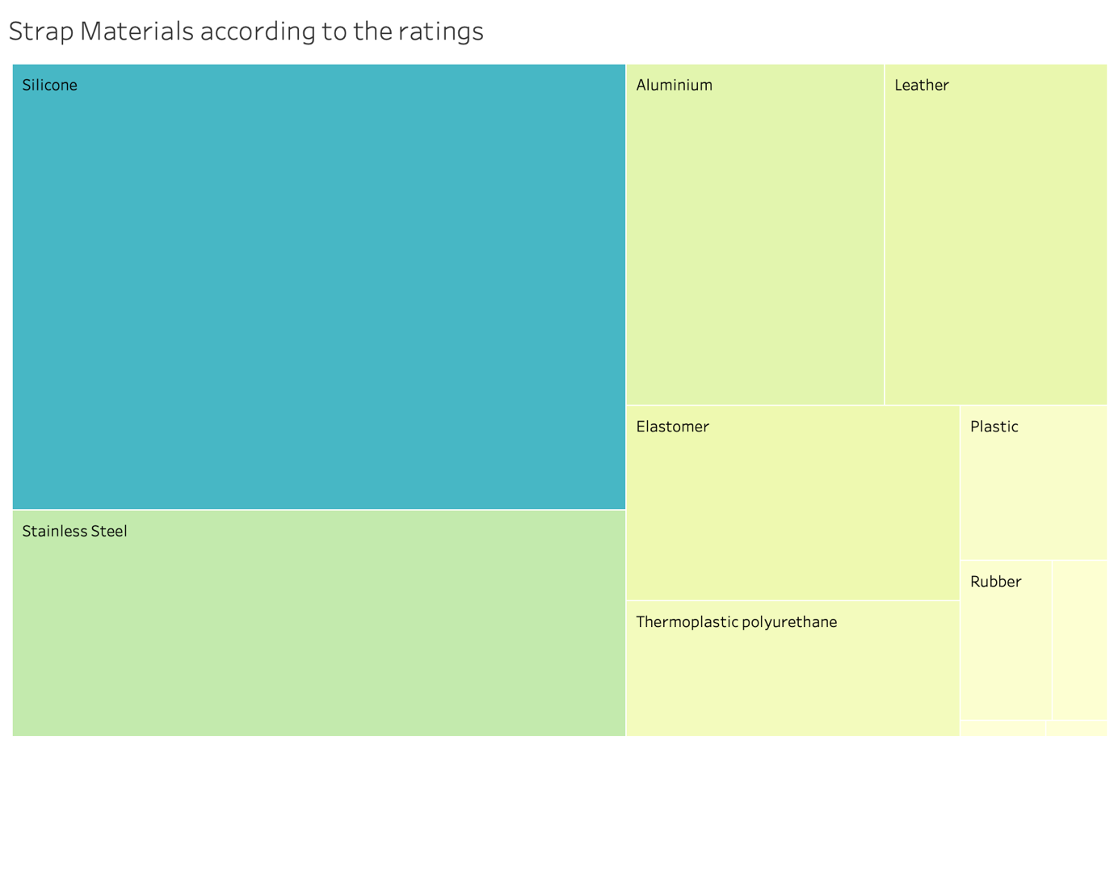

**Question 2:** What fitness brand is the most popular among the users according to the ratings?

This graph indicates the most popular fitness tracker brand among the users. This will help Shane to support to select a better fitness tracker brand when purchasing the fitness tracker for his long term usage.

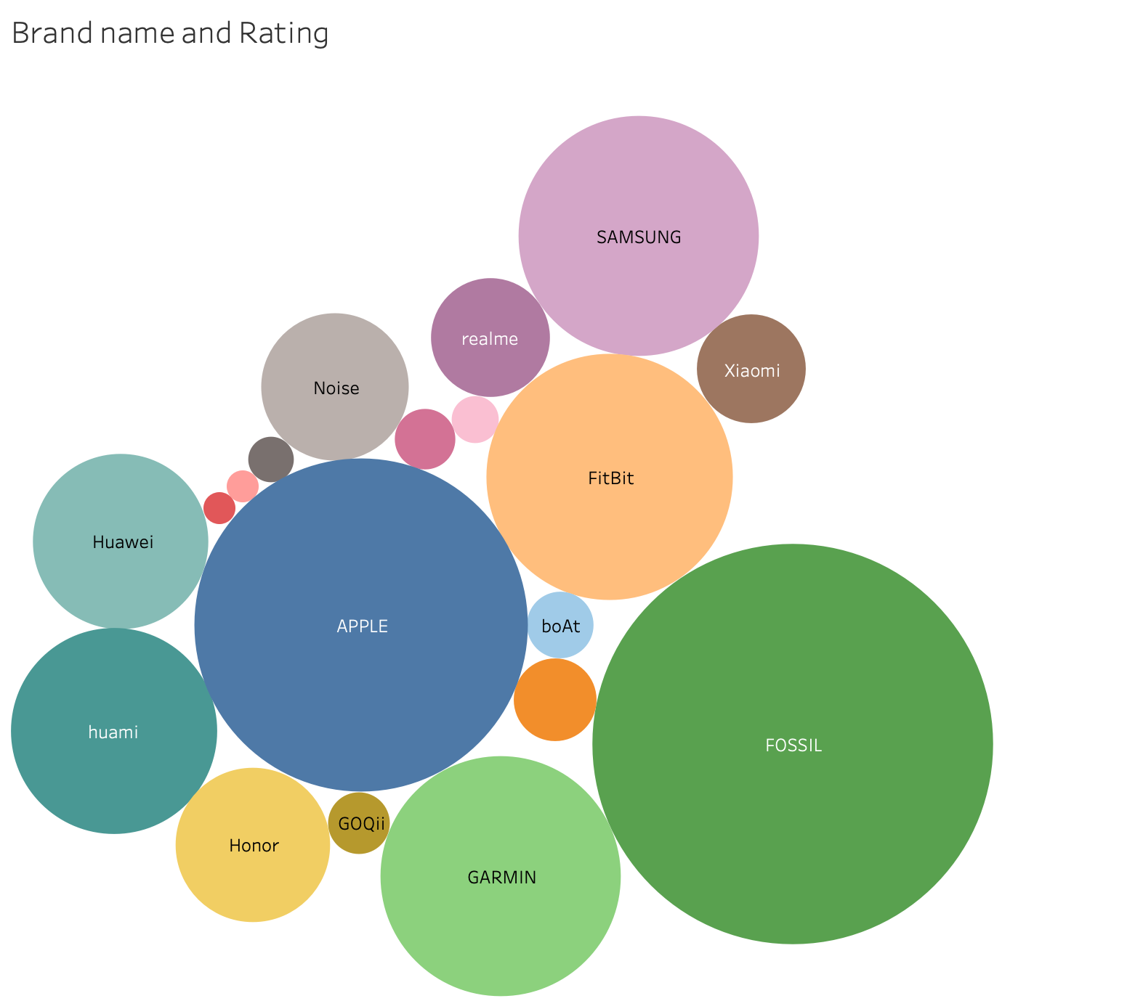

**Question 3:** What is the most affordable Fitness trackers according to Shane’s budget?

This graph indicates the difference between the Selling price and the original prices of the fitness trackers By looking at this graph the customers will be able to get a clear idea of which fitness tracker is much cheaper and will fit Shane’s budget.

**Question 4** : What fitness tracker has the best average battery life as Shane will be using the device throughout the day?

This graph indicates the Average life battery in the fitness tracker devices in all the brands the Therefore this will be helpful to Shane to decide which fitness tracker would be much worth it for his long term usage.

